05 ADR

ADE: Adverse Drug EVENT

ADE: a drug that causes injury

ADR***

Medication error

ADWE (Adverse drug withdrawal events):

1. Opioid,
2. Beta blockers b/c of down regulation of receptors
3. Clonidine (direct acting alpha 2 adrenergic agonist in brain) causes rebound hypertension

Non-compliance

Poisonings (children)

Adverse Drug Reaction: Definitions

ADR by WHO: Response to a drug which is noxious and unintended (doses used in humans)

ADR by ASHP: 1. complicates a disease state

2. Causes hospital admission

3. patient needs supportive therapy

4. prolongs hospitalization

5. leads to drug discontinuation

ADR Statistics

50 % ADR are considered preventable

Admission to hospital due to ADR 3 – 6%

Elderly admissions due to ADR 10 – 15% (doubles)

Elderly use 5 – 8 medications (over 50% ADR)

ADR in hospital: 10 – 30%

Serious ADR in hospital 7%

Type A ADR

Type A: Predictable thus preventable 70 – 80% of ADR

Augmented therapeutic effect (higher than usual) bleeding from Warfarin, Hypoglycemia from insulin

Drug effect on another site alopecia (lose hair) from chemotherapy

Drug has multiple effects antihistamine stops allergy AND goes to CNS 🡪 sleep

Ex: Trovafloxacin floxacin blocks DNA gyrase (antibiotic) & inhibit GABA . 🡪 patient began to have seizures

Type B ADR 🡪 General

Type B: Not predictable 20% of ADR

Immunologic

Allergic Reactions (10% of population) rash, hives, angioedema (swelling), fever, anaphylactic

Idiosyncratic non-immunological [hypersensitivity](http://en.wikipedia.org/wiki/Hypersensitivity) to a substance, . without connection to pharmacological toxicity

Pseudo allergy

Type B ADR: Immunologic 🡪 Allergy

Phase 1 allergy: Initial Sensitization drug binds to Hapten

Phase 2 allergy: Elicitation drug + Hapten causes immune response

Classification

1. Type 1: Anaphylactic plasma cell secretes IgE, IgE binds to mast cells and . basophils 🡪

mast and baso become sensitized 🡪 if . exposed again, mast and baso secrete histamine, . leukotriene and prostaglandins 🡪 cause

vasodilation 🡪 .cause hypotension 🡪 shock

1. Type 2: Cytotoxic
2. Type 3: Immune Complex
3. Type 4: Cell mediated antigen

Type B ADR: Non-Immunologic 🡪 Pseudo allergy

Pseudo allergy: Looks like allergy w/o immune system

Vancomycin (antibiotic) causes red man syndrome. Releases histamine w/o immune system

Ta**X**ol (Used to treat cancer) contains cremaphor (emulsifier) and Yew (taxus brevifolia) oily base excepient

Yew is an oily base excipient

Cremaphor is used to emulsify the Yew 🡪 IV causes pseudo allergy

Solve Cremaphor problem: Prevent with antihistamines & inject slowly

Iodine’s large size and osmolar triggers histamine w/o immune response

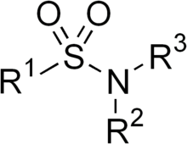Cross Sensitization ADR

1. Beta lactam Penicillin and Beta lactam like Cephalosporin has LESS than 2% cross sensitivity
2. Sulfa: allergic to whole structure

PK: Distriution

Hypoalbumenia causes too much anticoagulant

Free warfarin = anticoagulant

Warfarin + albumin = inactive

Malnutrition has little albumin 🡪 higher concentration of free warfarin

PK: Metabolism 🡪 CYP450

Warfarin + Amiodarone

Warfain gets metabolized by CYP 3A4 and 2C9.

Amiodarone (K channel blocker for arrhythmia) inhibits CYP 3A4 and 2C9.

Warfarin increases 🡪 anticoagulant

Solve: give less warfarin, check symptoms

Cyclosporin + Rifampin

Cyclosporin is an immunosuppressant for organ transplants

Low dose causes organ reject

High dose = cancer

Rifampin induces CYP 🡪 low levels of Cyclosporin

PK: Elimination

Lovenox (Enoxaparin) 🡪 can cause kidney failure 🡪 check CrCl

Race

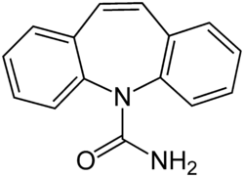Carbamazepine (anticonvulsant) skin reaction AZIN + PAIN

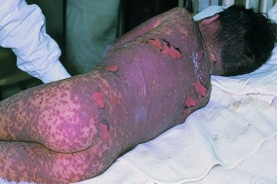

Pregnancy

Category X and D drugs

- THALIDOMIDE

- Statins

- Warfarin

- Sulfonylureas (diabetes)

- Aneiepileptic drugs

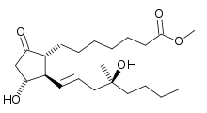 - NSAID (3rd trimester)

- Misoprostol